Chakradhar Bhogapurapu, BIBA.

CLASS 3

COUNT, GROUP BY(), ORDER BY(), HAVING.

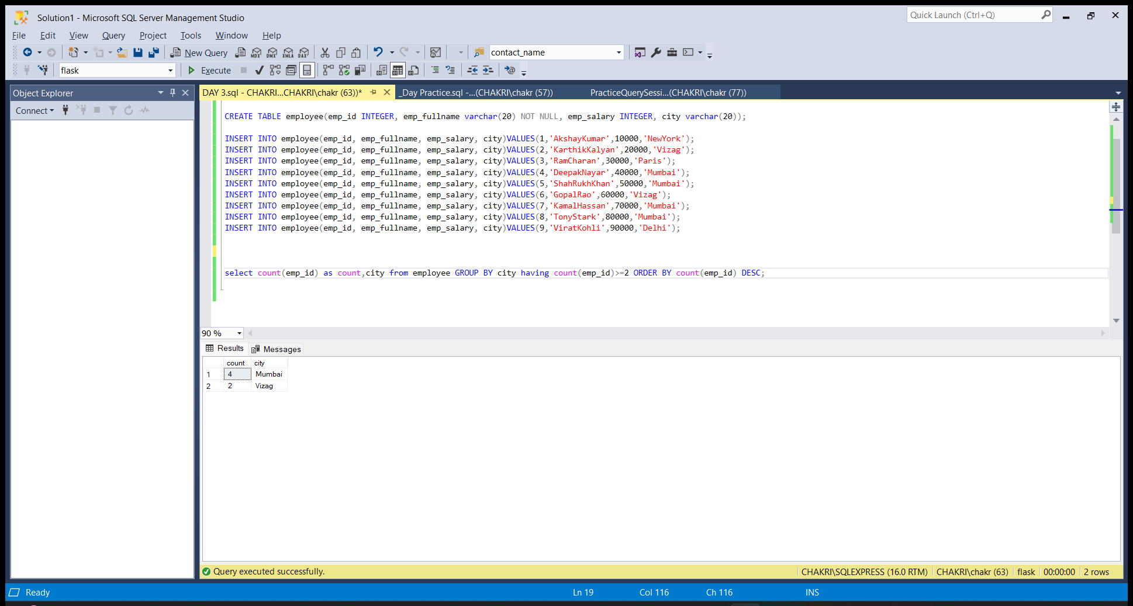

TCL COMMANDS

* COMMIT

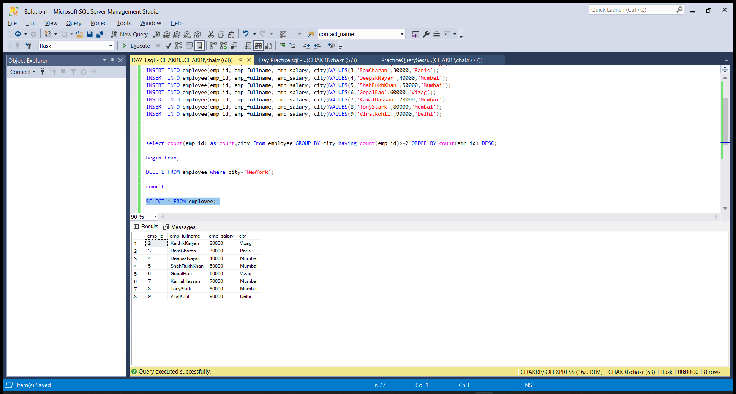

* ROLLBACK

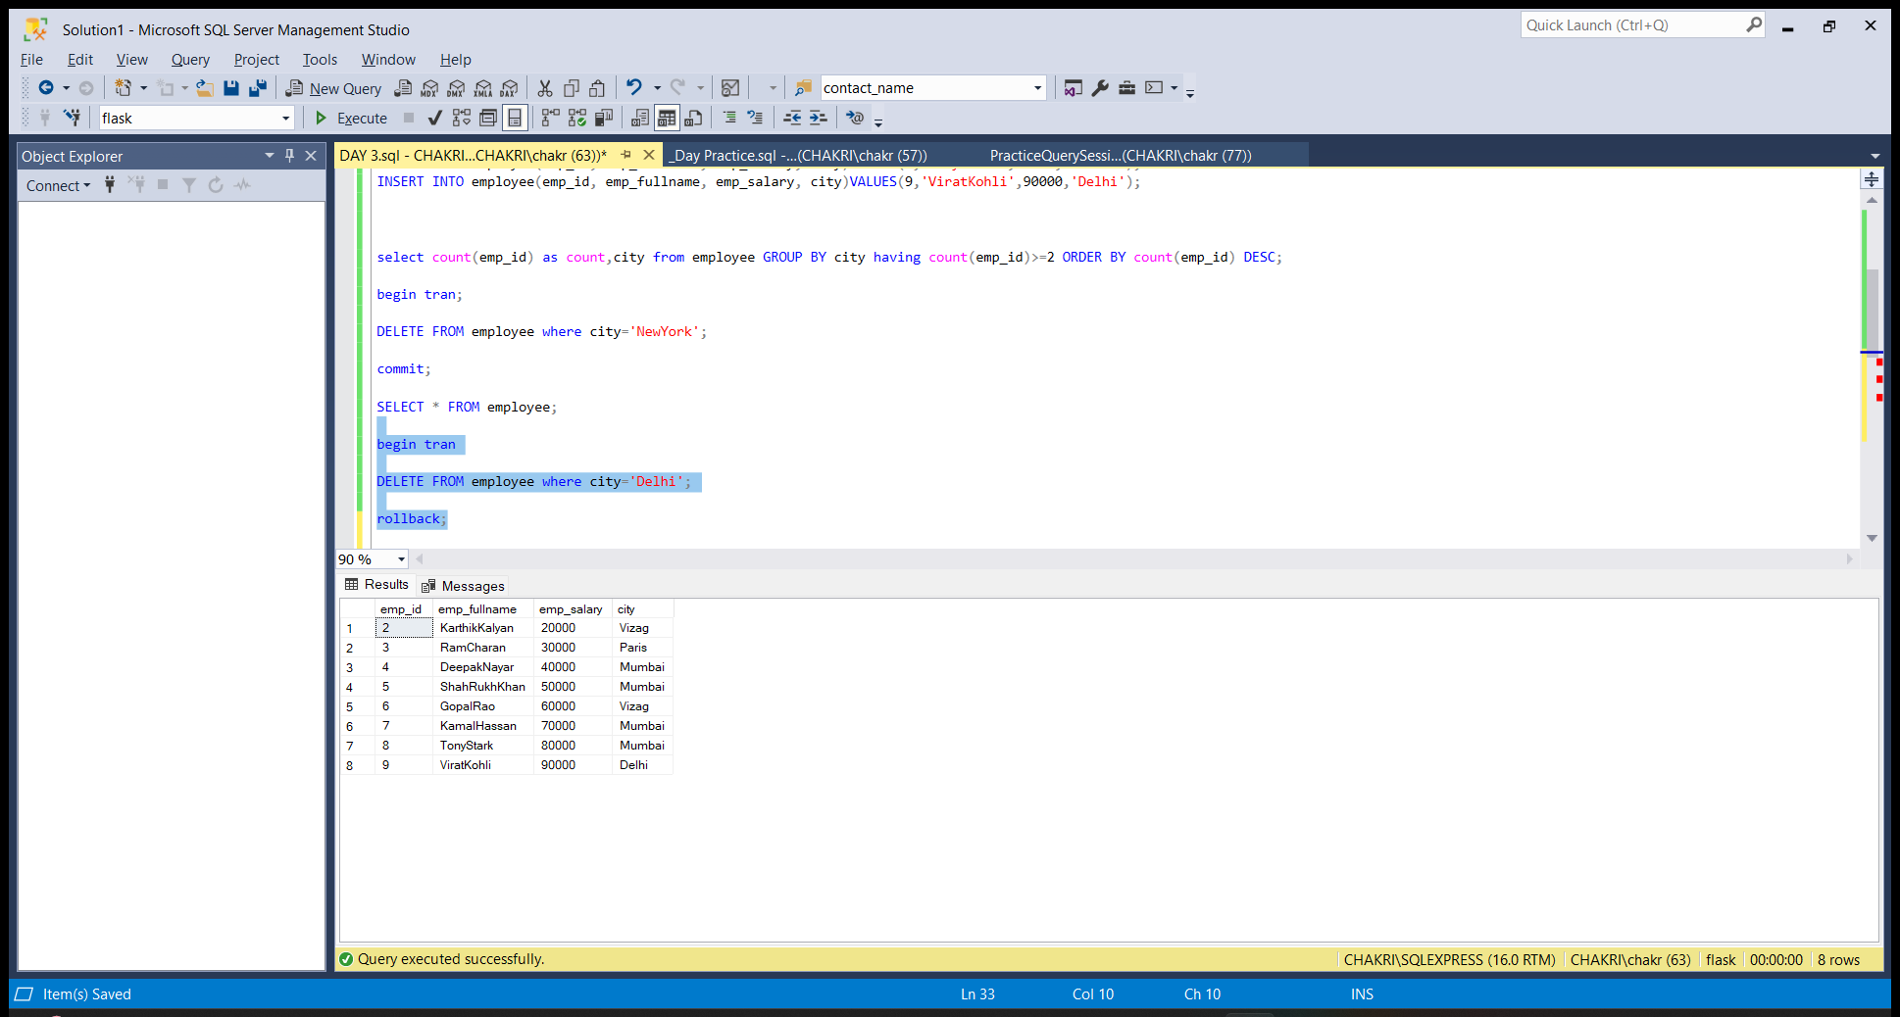

* SAVEPOINT

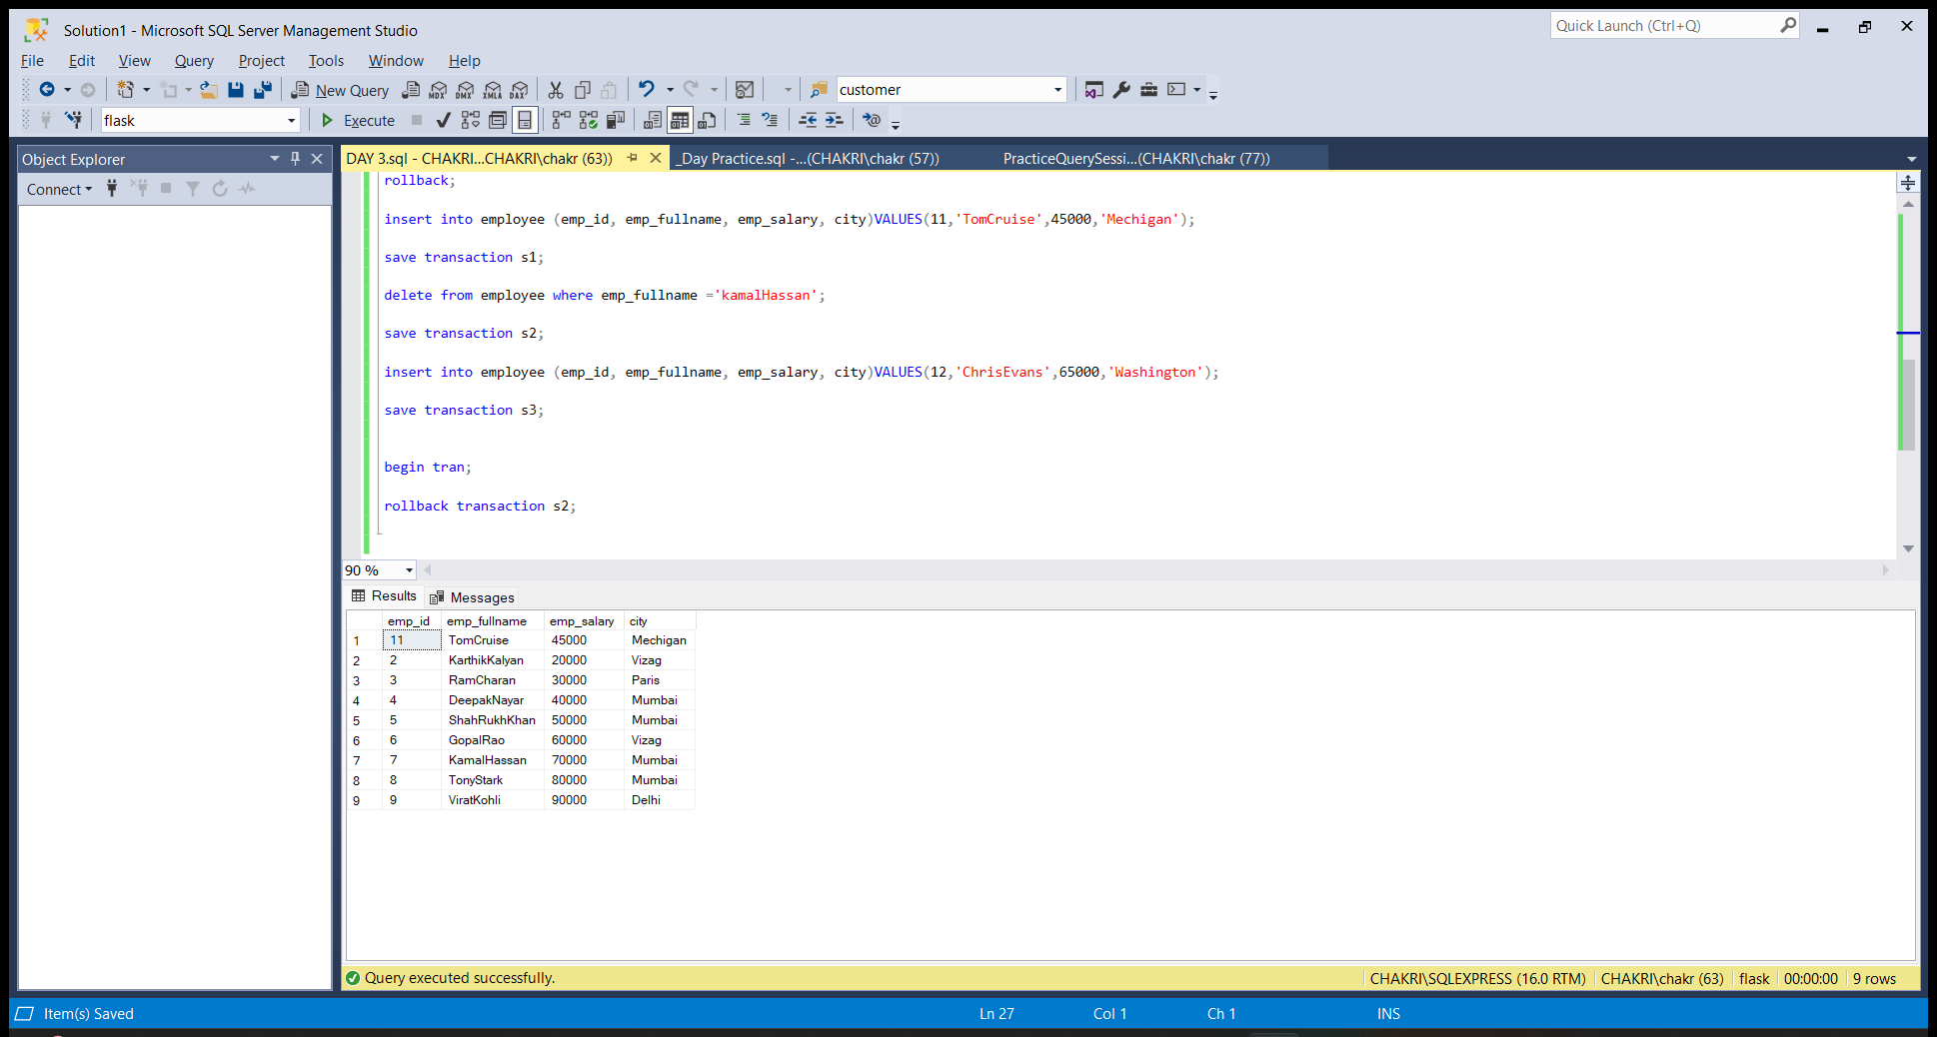

AGGREGATE FUNCTIONS

* DISTINCT

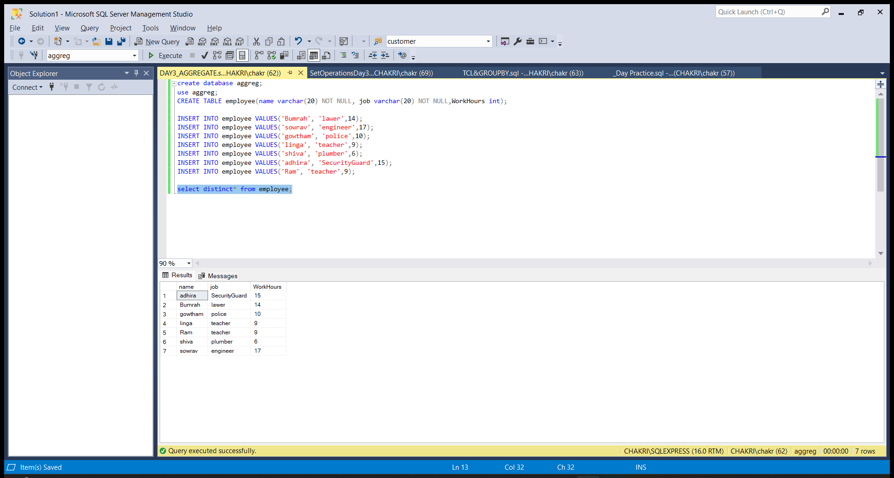

* SUM()

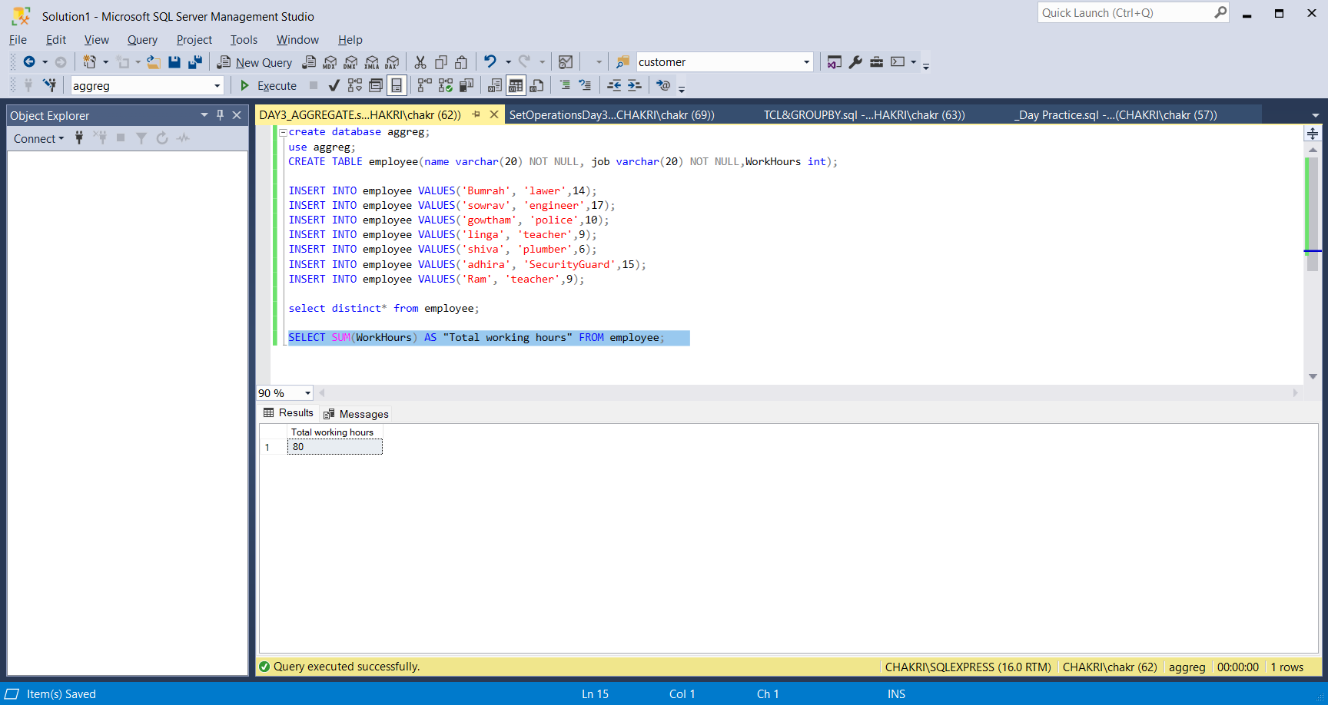

* AVG()

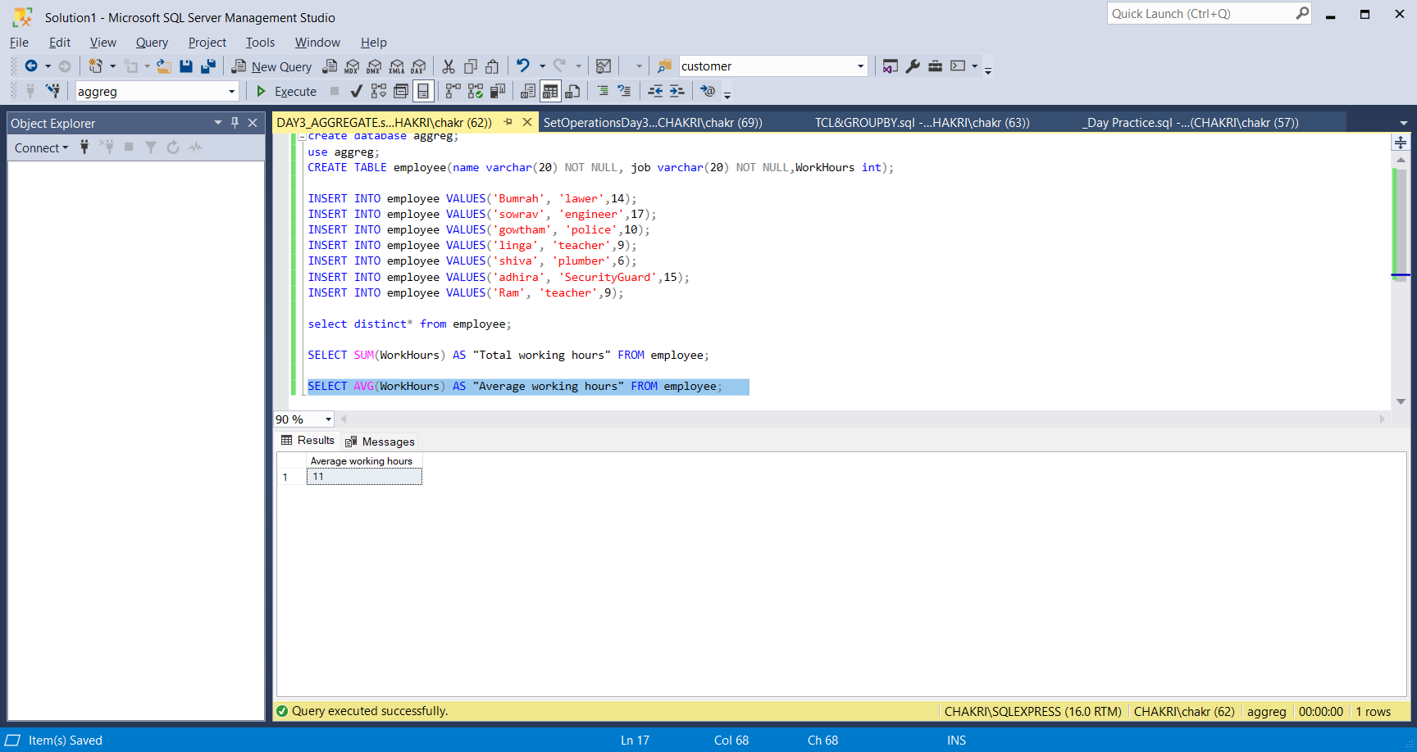

* MIN()

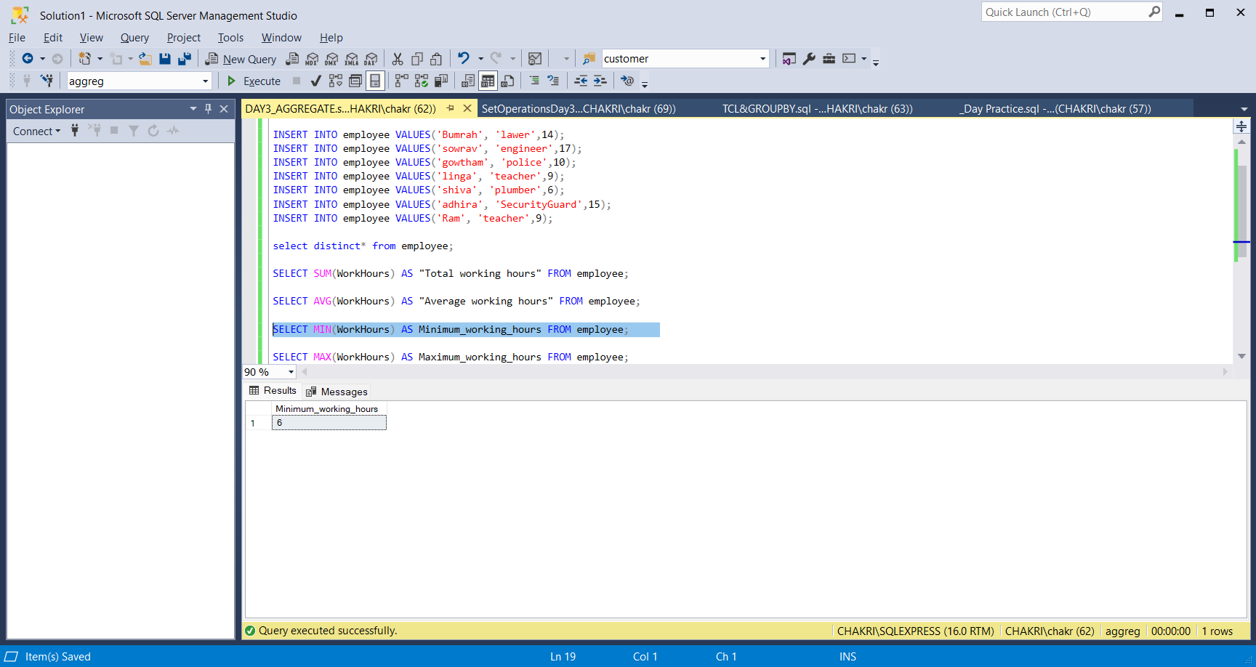

* MAX()

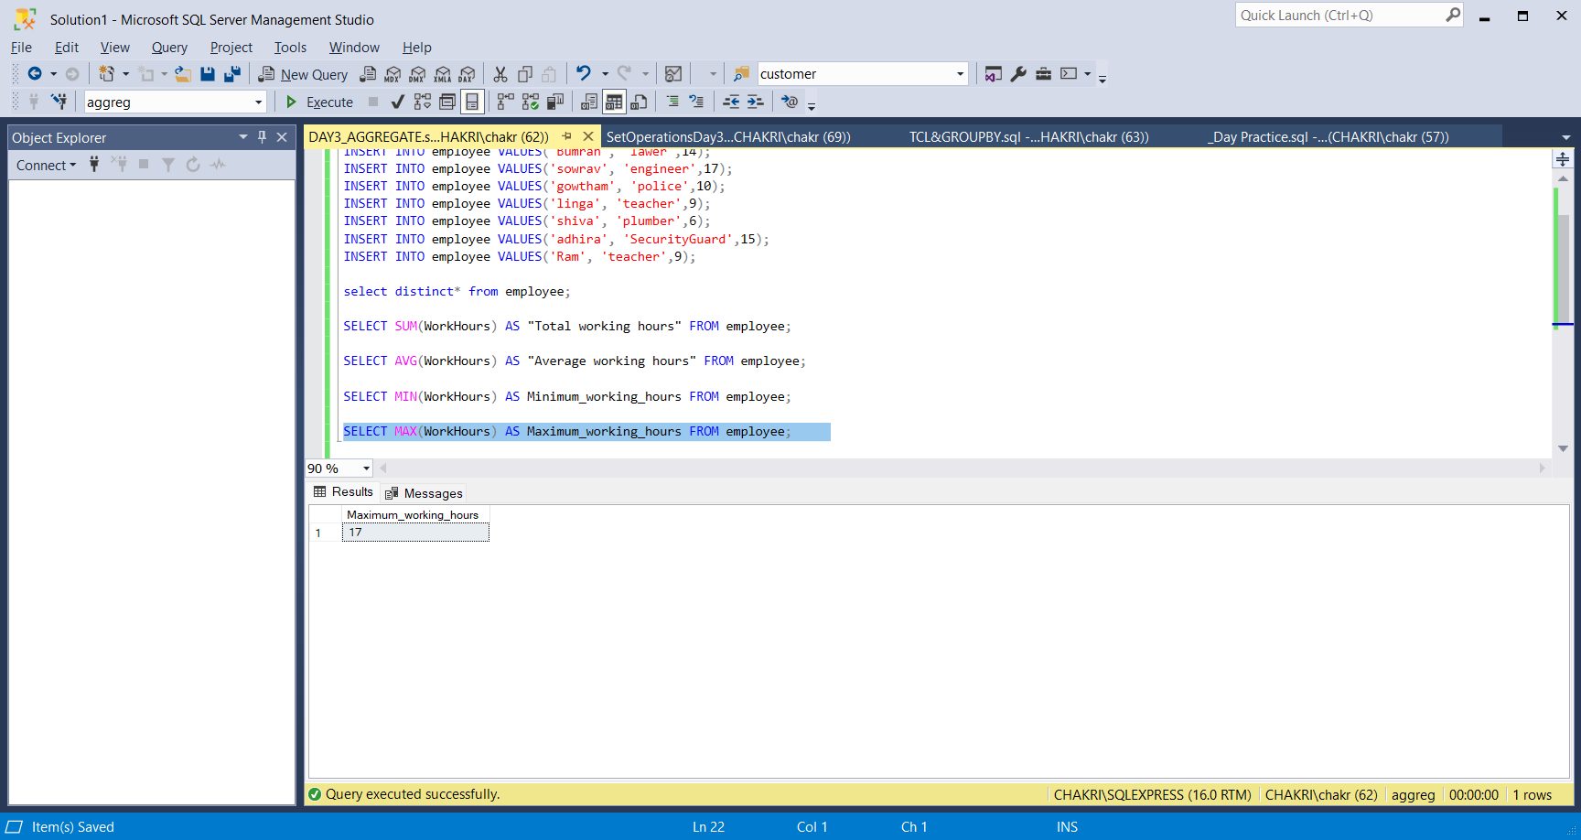

SET OPERATIONS

* UNION

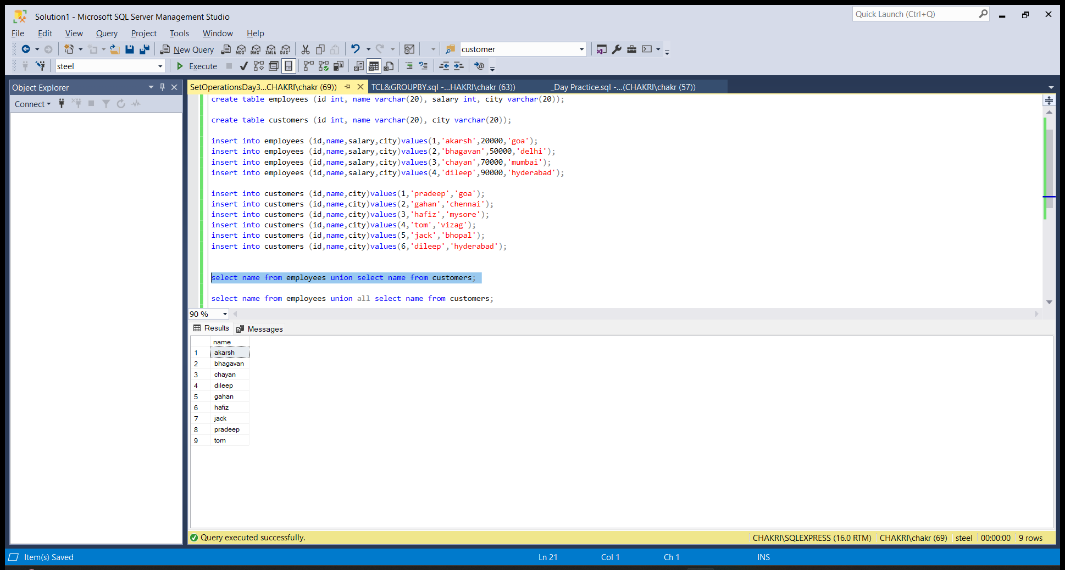

* UNION ALL

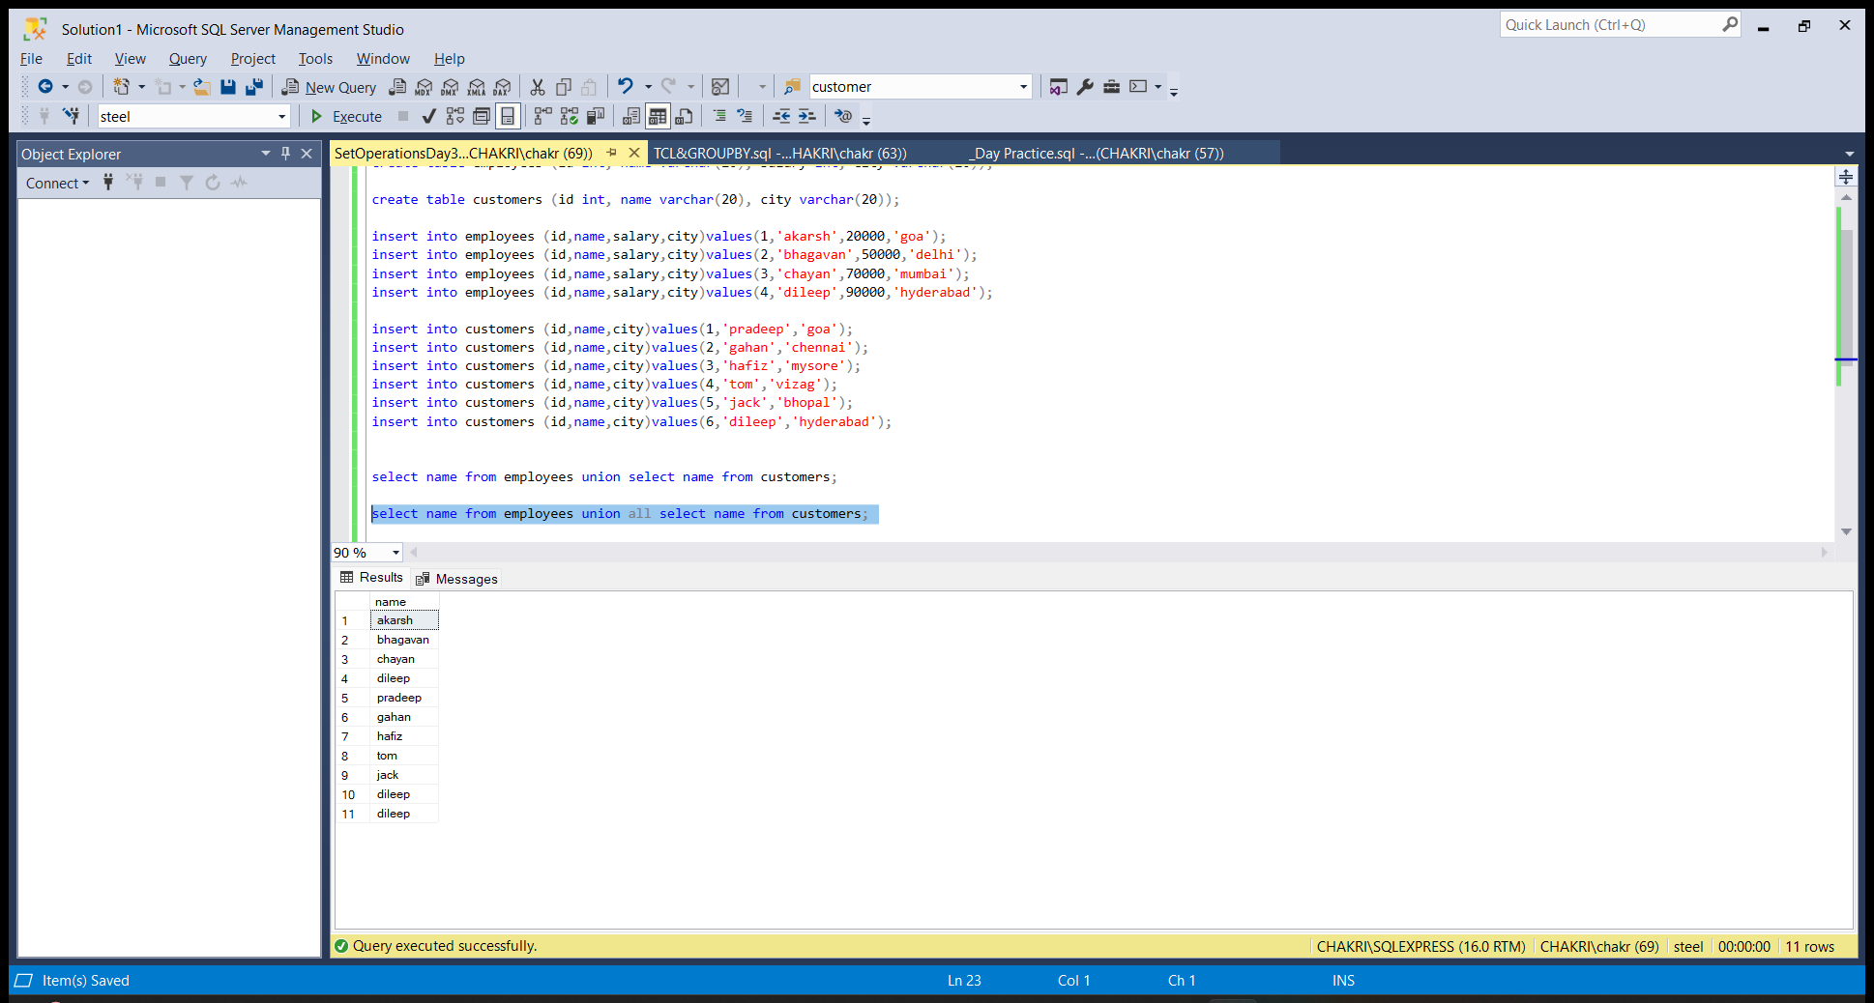

* INSERSECT

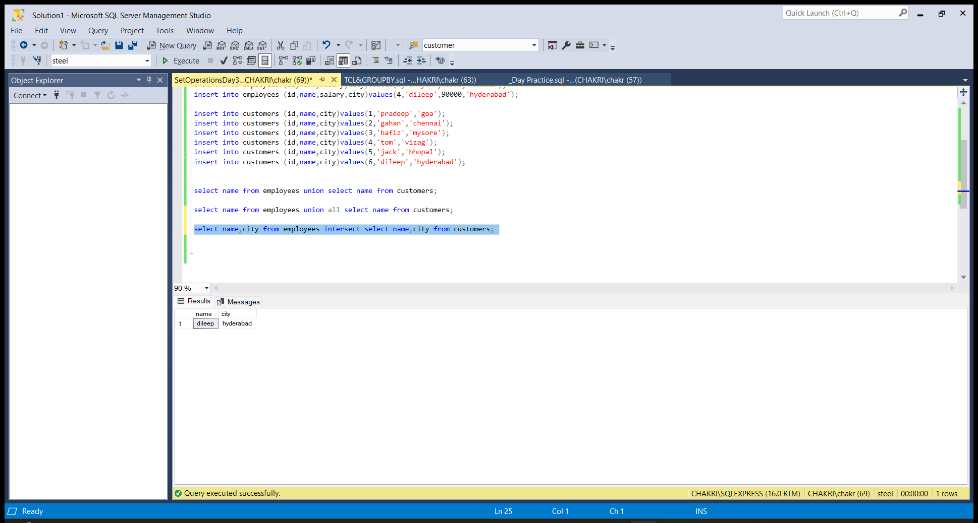

KEY CONSTRAINTS

PRIMARY KEY, NOT NULL, UNIQUE, DEFAULT, CHECK, FOREIGN KEY

